- EXPRESSION OF INTEREST (EOI)

EOI Reference #: ASMC-WRTI-EOI-2023-006
Title: SE807 – PCBS Crew Shelter
Project: West White Rose CGS Tow-out & Installation

Issue Date: May 23, 2023
Closing Date: Jun 6, 2023

GENERAL
Aker Solutions Marine Contractors Limited (ASMC) hereby invites interested parties to submit an Expression of Interest (EOI) related to the future Requests for Tender for the following Scope of Work in connection with ASMC CGS Tow-out and Installation Scope of Work for the Cenovus West White Rose Project in Newfoundland and Labrador, Canada.

BENEFITS COMMITMENTS
ASMC is committed to providing full and fair opportunities to commercially competitive Canadian companies with first consideration given to those from Newfoundland and Labrador. At the Pre-Qualification and ITT stages, companies will be required to complete Canada/Newfoundland & Labrador Benefits questionnaires to acknowledge their willingness to comply with the White Rose Canada-Newfoundland and Labrador Benefits Plan.

EQUAL OPPORTUNITY
ASMC is an equal opportunity employer and as such supports diversity in the workplace. Successful suppliers and subcontractors to ASMC will be required to undertake a commitment to support diversity in execution of work on the West White Rose Project.

SCOPE OF SERVICES

Specific service requirements shall include, but not be limited to the following:

The scope of supply comprises:
- One (1 each) 20’ long x 8’ wide x 8’ high DNV 2.7-1 container outfitted with:
  - Four (4) certified and inspected lifting pad-eyes suitable for a 4-legged, single point offshore lifting,
  - Four (4) standard ISO corner castings suitable for installation of twist locks,
  - 4-legged bridle (complete with wire rope slings, Masterlink, thimbles and shackles) for installation and removal, designed, inspected, and tested to DNV 2.7-1.
  - 80” tall x 36” wide exterior steel door, outswing with ‘crash bar’ on interior side of door,

  - Escape hatch, located as far as practicable away from the main access/egress door,
  - A0 fire rating,
  - Interior / exterior lighting,
  - 115V electrical receptacles,
  - Space heater(s) with thermostat control (3-phase rated for 208Vac or 1-phase rated for 208Vac or 120Vac),
  - Fire/heat and smoke detectors with sirens and strobes for internal and external indication of fire related emergencies in the containers,
  - Two (2) 5 lb Class A/C manual fire extinguishers with mounting brackets,
  - Slip resistant floor coverings,
  - Flame resistant wall, ceiling, and floor coverings (e.g. very light gauge steel on walls and thin ‘checkered’ (slip resistant) plate on floors),
  - R20 insulation in walls and ceiling,
  - R10 insulation in floor,
  - Interior furnishings (small table, chairs, small kitchen appliances etc.)
  - All equipment / devices requiring electrical power are to be pre-wired back to 208/120 Vac a distribution panel integral to the crew shelter container. There shall be an allowance (i.e. means of penetrating the container wall) for the connection of the main incoming power supply (by Purchaser) to the shelter. The electrical equipment for the shelter shall be installed in compliance with CSA standards (i.e. CSA C22.1) and certified to CSA standards by an electrical certifying authority.
- All welding and coatings procedures and inspections shall be as per project specifications.
- Documentation.
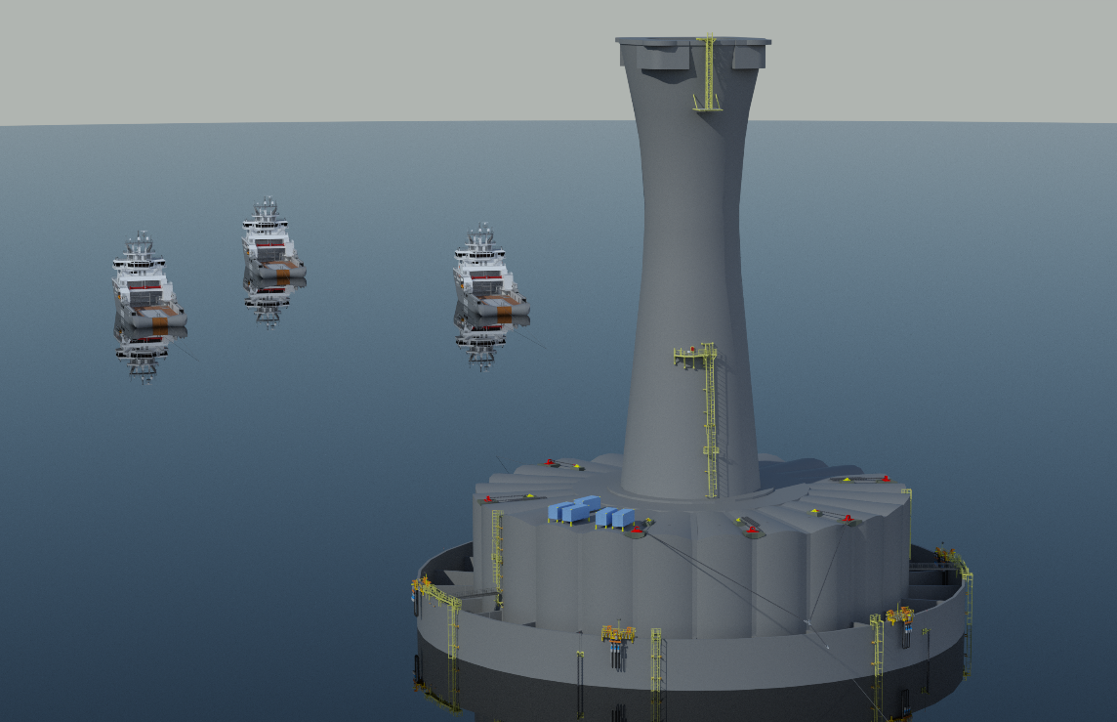
Crew Shelter
- Figure 1 – PCBS Container Arrangement on CGS Caisson Roof
SCHEDULE AND DELIVERY
Required On Site date (Tentative): March 15, 2024
Delivery Location: CGS Construction Site at Argentia, NL
SUBMISSION REQUIREMENTS

As part of the submission requirements, suppliers are requested to provide Aker Solutions Marine Contractors Limited with the following answers and/or information:
- Please provide a brief outline of the following company information:
  - Copy of Certificate of Incorporation.
  - Company Name and Address.
  - Single Point of Contact, c/w contact details.
- A list of previous work experience related directly to the scope of services including modification and outfitting of DNV 2.7-1 offshore containers as well as relevant experience coordinating third-party certification e.g., DNV, CSA etc. This list should include but not be limited to the client’s name, project date, location, specific industry sector and proposed manufacturer.

- Overview of your company’s equipment and tools maintenance and calibration/recertification program with specific reference to the database being used to manage this.

- Please provide a brief description and overview of the execution plan and facility being proposed to execute the work, including a high-level schedule, from contract award to delivery at the Cenovus WWRP CGS Construction Site in Argentia, NL.

RESPONSE REQUIREMENTS

Suppliers are to respond to the following e-mail address: ASMC.WRTI_Procurement@akersolutions.com
on or before the closing date noted above.

The subject line of the email must contain the following:
EOI REFERNCE NUMBER – TITLE – Supplier Company Name

Suppliers that have not been pre-qualified will be required to do so before the formal RFQ/Tender/Bid packages.

If you have any questions regarding this announcement, please contact Aker Solutions Single Point of Contact listed below:

Tanya O’Neill
Contracts Manager
Aker Solutions Marine Contractors Limited
- tanya.oneill@akersolutions.com

